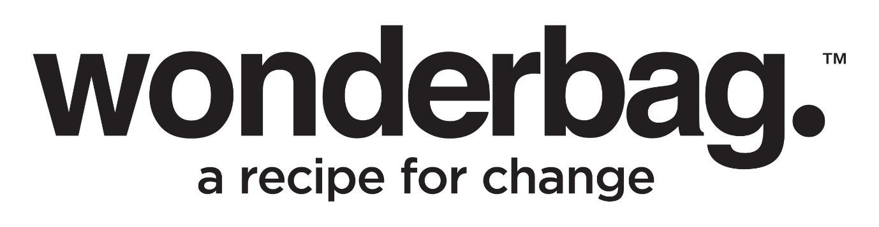

Press Release
Embargo : Tuesday 18 July 2023

6,700 Wonderbags for KZN to celebrate Mandela Day

In celebration of Mandela Day, Wonderbag, a South African company based in Kwazulu-Natal, is making 6,700 Wonderbags available in local communities at a special price of only R30 each. The initiative aims to address the challenges faced by many South Africans due to the rising cost of living and the ongoing energy crisis.

Starting on Monday, 17th July, Wonderbag's Mandela Day promotion will continue until all 6,700 units are sold at the significantly reduced price. To take advantage of this amazing offer, individuals can visit Wonderbag's factory located at 9 Walter Reid, Tongaat Industrial Park. Remember to bring along your ID.

In addition to the Tongaat factory, Wonderbag will set up pop-up sales stands in various communities in Kwazulu-Natal on July 18th. One of these stands will be located at Mzinyathi Matabetulu in Inanda, operating from 7:30 am to 4pm. Keep an eye out for a Wonderbag activation in your area.

Those unable to get to Tongaat or one of the community sales areas, are able to purchase online from www.mywonderbag.co.za. On the 18th July only, online shoppers can purchase two Wonderbags for R67 including delivery. This ensures that all South Africans will be able to benefit from the Mandela Day initiative and have the opportunity to get a Wonderbag at a hugely discounted price.

The Wonderbag is a non-electric slow-cooker that originated in South Africa and has gained international recognition. Renowned figures such as Jane Goodall and Jamie Oliver have endorsed this innovative portable heat-retention cooker. The Wonderbag can continue cooking food for up to 12 hours without the need for electricity, providing a practical way to prepare nutritious meals, and also reduce your household electricity costs.

Offering the Wonderbags at the hugely reduced price for Mandela Day, is part of Wonderbag’s vision to be part of the solution to the energy crisis, poverty and rising costs of living in South Africa.

For more information about the Wonderbag and its benefits, please visit Wonderbag's website at http://www.mywonderbag.com/. Stay connected with Wonderbag through the following channels:

WhatsApp: 060 628 9437
Instagram: @TheWonderbag
Facebook: Facebook.com/TheWonderbag
Twitter: @WonderbagO

ENDS

WORDS  PICTURES  DISTRIBUTED  DATE | :  :  :  : | 346  Images of the Wonderbag  On behalf of Wonderbag  July 2023

Notes to Editor:

About Wonderbag
The Wonderbag is a revolutionary, non-electric, heat retention cooker that allows food that has been brought to the boil by conventional methods, to continue cooking for up to 8 hours, without using an additional energy source. Not only is the Wonderbag a revolution in the kitchen, but it is also a recipe for social change. The world has embraced the Wonderbag because of its environmental attributes and particularly its social contributions – that includes it being coined by carbon and climate change experts as, “the only scalable carbon offset project in existence”.

Wonderbag is one of the fastest growing registered carbon projects in Africa and is changing the model of aid as we know it. In South Africa, Natural Balance has registered the Wonderbag project as a carbon offset project, unique to any other carbon offset project in South Africa. The Wonderbag offset has significant sustainable development benefits.

Wonderbag was founded in South Africa in 2008 by local entrepreneur and social activist, Sarah Collins, and the product was born out of a practical desire to continue cooking during a bout of Eskom load shedding. Since opening its doors, the company has grown exponentially, and this local product has crossed over borders into various overseas markets.

For more information or visuals, please contact Janna Strang on
janna@rainmakermarketing.co.za / 082 551 3865 or email tasha@rainmakermarketing.co.za

